# MICROCOMPUTING SYSTEMS

# 

Ana Cifuentes Romero

DW1E – 09-02-2022

# Identify all the different components you know in the following motherboards.

**Number 1**

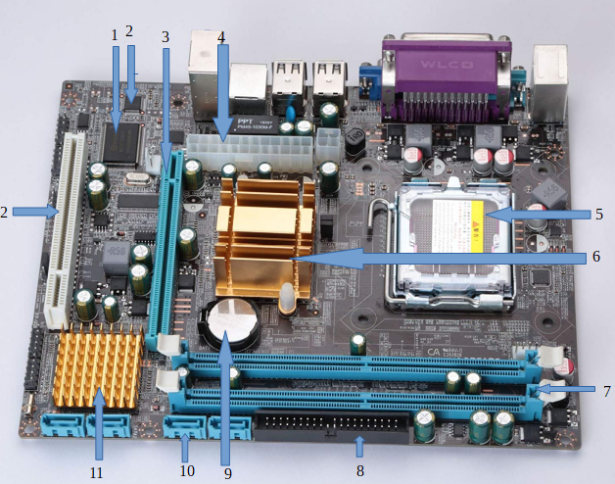

**1.- Flash memory:** is an electronic (solid-state) non-volatile computer storage medium that can be electrically erased and reprogrammed. It can keep stored data and information even when the power is off. The two main types of flash memory, NOR flash and NAND flash, are named for the NOR and NAND logic gates. NOR and NAND flash use the same cell design, consisting of floating gate MOSFETs.

**2.- CMOS memory:** Complementary metal-oxide-semiconductor (CMOS) is **a small amount of memory on a computer motherboard** that stores the Basic Input/Output System (BIOS) settings. The BIOS is the software stored on the memory chip on the motherboard.

**3.- PCI Express x16:** is a high-speed serial computer expansion bus standard, designed to replace the older PCI, PCI-X and AGP bus standards. It is the common motherboard interface for personal computers' graphics cards, hard disk drive host adapters, SSDs, Wi-Fi and Ethernet hardware connections.

**4.- ATX Power Connector x24:** is found on motherboards within a computer case. This connector provides power to cooling fans and is typically used on the fan that cools the CPU.

**5.- CPU Socket:** contains one or more mechanical components providing mechanical and electrical connections between a microprocessor and a printed circuit board (PCB). This allows for placing and replacing the central processing unit (CPU) without soldering.

6.- Northbridge:

**Number 2**

3 pin case fan connector

4x PCIe Slots

Back panel and I/O connections

Audio header

PCI Slot

PCI Slot

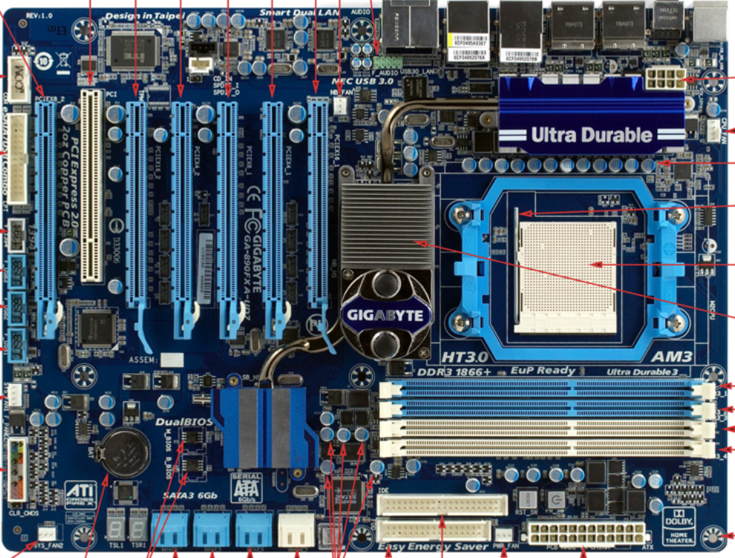

3x USB headers

North bridge

Screw hole

4x RAM Slots

CPU Socket lever

Capacitors

CPU Socket

Dual BIOS

EPS 8 pin CPU Power connection

4 pin CPU fan connector

Primary ATA (IDE) connector

Capacitors

System panel connectors

3 pin case fan connector

4 pin case fan connector

eSATA/USB combo header

1394 header

COM header

X24 ATX Power connectors

CMOS battery. Coin cell

SATA connections

South bridge

3 pin case fan connector

Floppy drive connector

**Number 3**

8 pin ATX Power connector

PCI

Rear Panel I/O Ports

PCI Express x1

PCIe x16

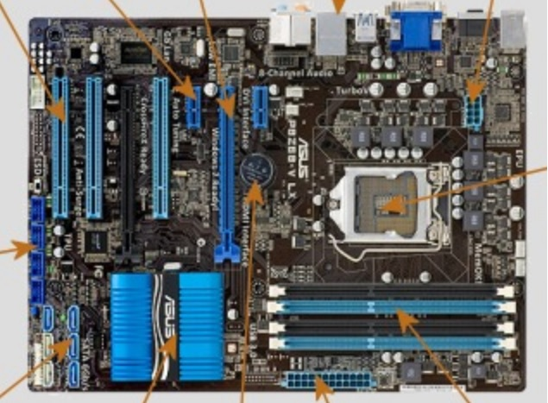

USB Ports

SATA Ports

Chipset PCH

4x RAM Slots

CPU Socket

CMOS battery

X24 ATX Power connectors

Number 4

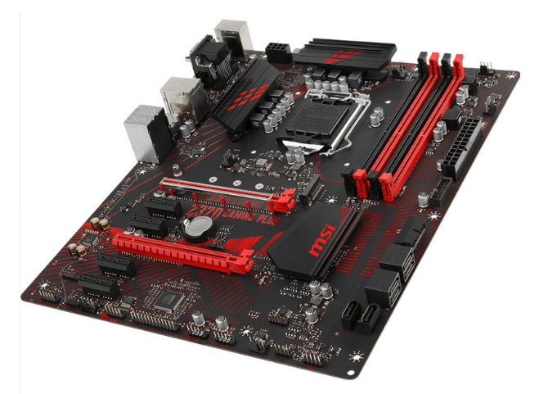

Number 5

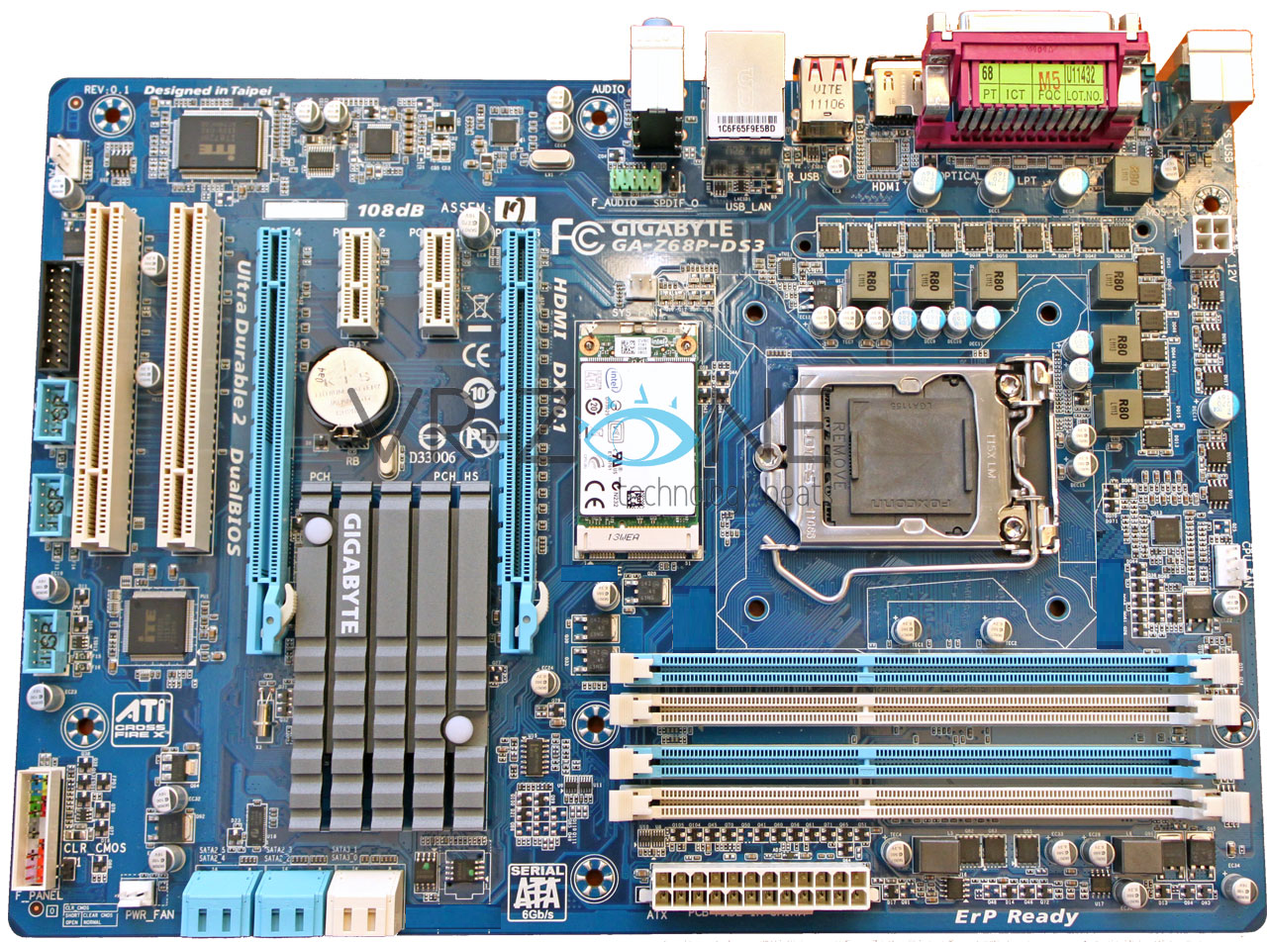

Number 6

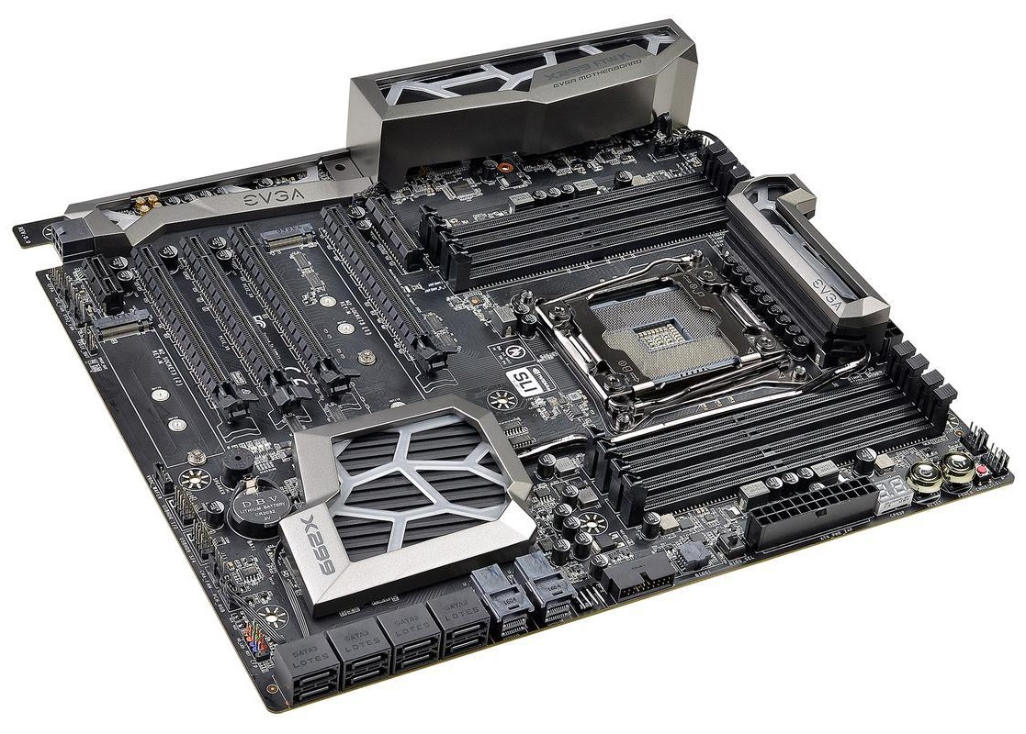

# Identify the external connectors in the following pictures

Number 1

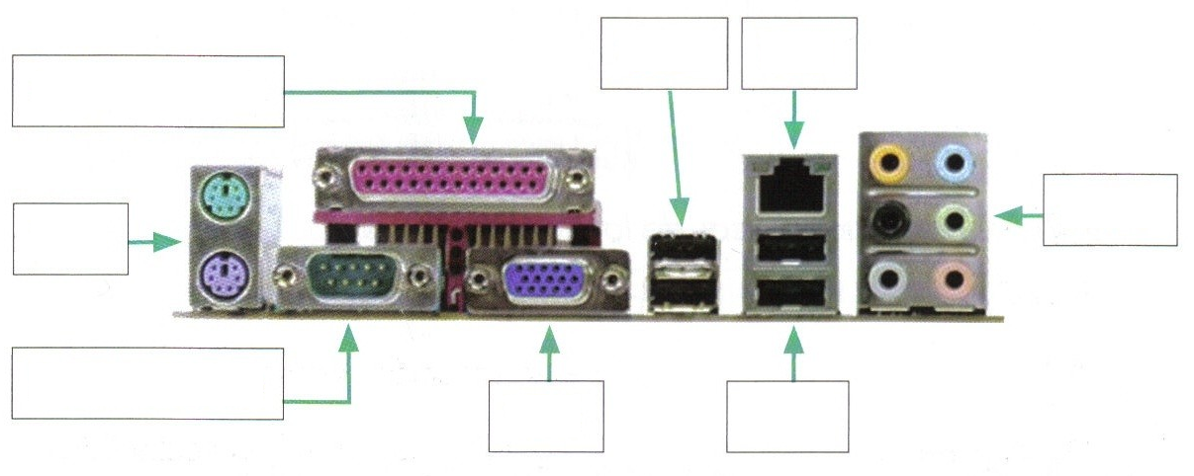

Number 2

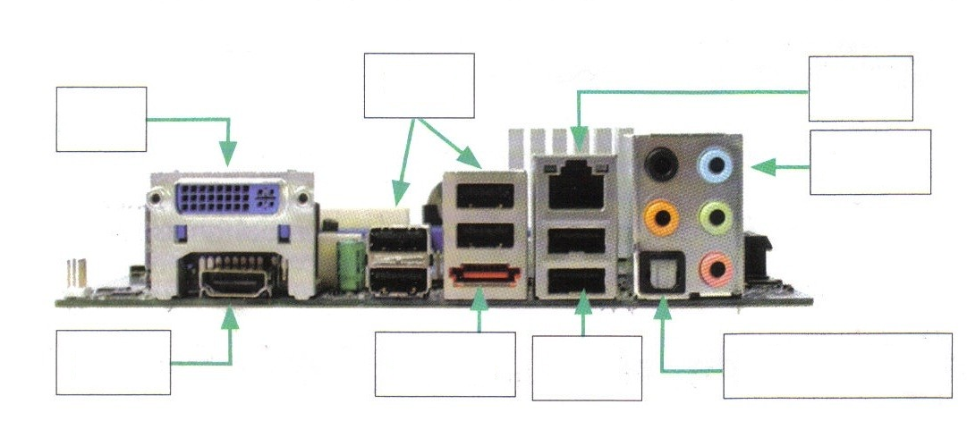

Number 3

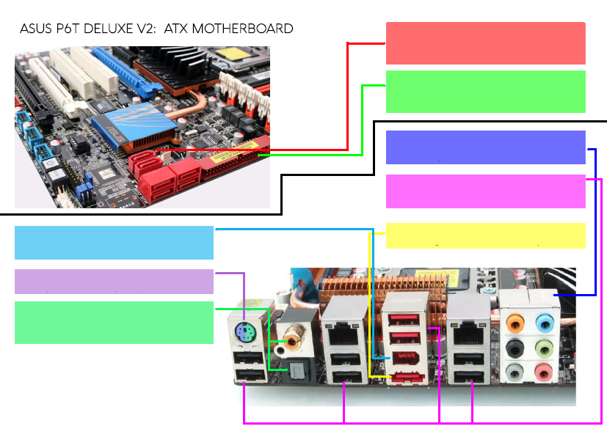

Number 4

